Pore network simulation of salt subflorescence growth in a porous medium.

Salt precipitation in porous media is of central interest in several applications, such as the salt crystallization induced damages in building materials, the underground storage of CO2 or the evaporation process from soils and the soil salinization issue, to name only a few. When the salt precipitates inside a porous medium, the resulting salt structure is called subflorescence (Fig.1). The experiment reported in [1] shows that the subflorescence is itself a porous structure and that its growth is controlled by the distribution of the evaporation flux at its boundary.

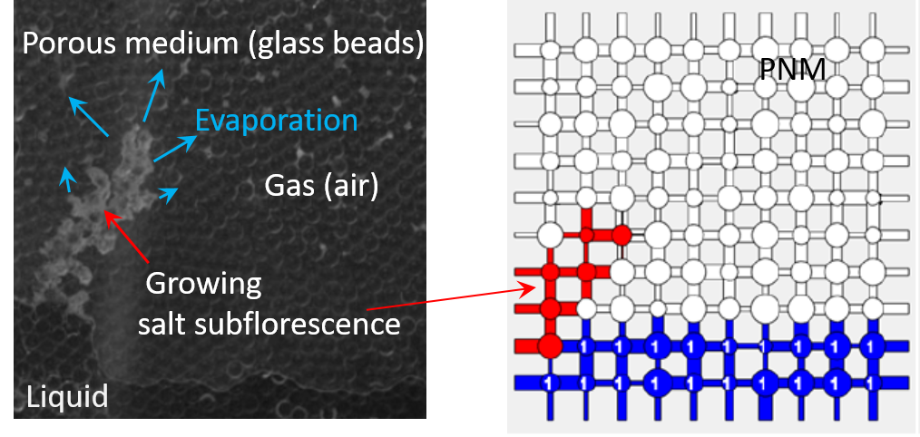
- b)
Fig.1. a) Salt subflorescence growing in a micromodel [1], b) Pore network simulation of the subflorescence growth.

The objective of the present work is to develop a pore network model (PNM) so as to analyze the subflorescence growth in more depth. The first step is to perform the simulation of the experiment reported in [1] where the subflorescence growth is observed in a 2D model porous medium made of a monolayer of glass beads sandwiched between two glass plates (Fig. 1a). The pore network model combines a drying algorithm [2] with the salt structure growth mechanisms identified in [1] and [3].
The main subflorescence formation and growth mechanisms will be described as well as the PNM developed. Simulations of the subflorescence development (Fig.1b) will be presented in conjunction with the experiment [1].

References

- N.Sghaier, S.Geoffroy, M.Prat, H.Eloukabi, S. Ben Nasrallah, Evaporation driven growth of large crystallized salt structures in a porous medium, Physical Review E 90, 042402 (2014)
- M.Prat, Recent advances in pore-scale models for drying of porous media, Chem. Eng. J. 86: 153-164 (2002).
- G.Licsandru, C. Noiriel, P.Duru, S. Geoffroy, A. Abou-Chakra, M.Prat, Dissolution-precipitation driven upward migration of a salt crust. Physical Review E 100, 032802 (2019).

