Pore scale modelling of stress-dependent permeability and tuorisity of hydrate bearing sediment based on high resolution synchrotron x-ray computed tomography imaging
Rui Li¹, Yingfang Zhou^{1*}, Wenbo Zhan¹, Jianhui Yang²
- School of Engineering, University of Aberdeen
- GRC, Total
Abstract
Gas hydrate contains abundant methane and is expected to be a promising energy supply to mitigate the influence of climate change in the future, in addition, it is also relevant to geological hazards. Permeability governs the gas production rate when extracting gas from hydrate deposits, which is a stress-dependent factor that varies while depressurizing the hydrate deposit. Probing the relation between permeability characteristics and effective stress is thus critical for better planning the gas production in hydrate reservoirs. However, the study of stress-dependent permeability of hydrate-bearing sediments is rare due to restricted access to in-situ hydrate-bearing cores and the sensitivity to pressure and temperature disturbance of hydrate-bearing cores.
In this work, we constructed a set of hydrate-bearing rock models with a wide hydrate saturation range based on high-resolution synchrotron x-ray computed tomography imaging. We then adopted the Finite Element Method to investigate the deformation of these hydrate-bearing rock models under different effective pressures. The deformed pore space was then used as input for direct single phase flow using a Lattice-Boltzmann method.
The proposed simulation approach was first validated using capillary tube models (see Figure 1). The porosity and permeability results demonstrate that the deformation-flow coupling workflow proposed in this work is valid (see Figures 2 and 3). The simulation in realistic hydrate bearing sediments extracted from high resolution synchrotron x-ray computed tomography imaging were performed under various hydrate saturation to understand the effect of effective stress on permeability and tuorisity of the hydrate-bearing rock.
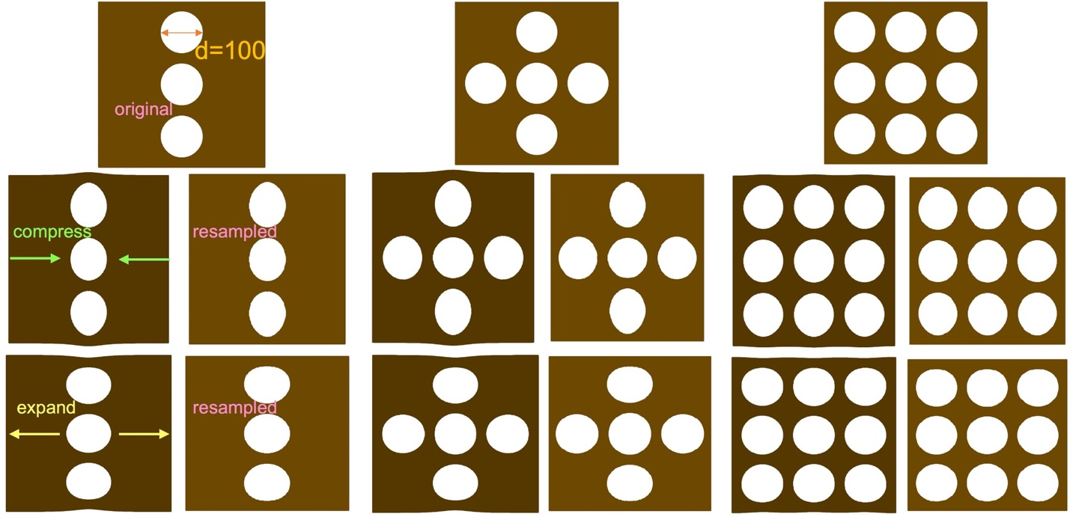
(a) Model 1 (b) Model2 (c) Model3
Figure 1 Cross-sections of capillary tube models with a resolution of 1.2 um. Models in the first row are original models that have a different amount of capillary tubes with identical diameters. Models in the second row represent the models after applying a compressing force, and resampled marks represent the models after resampling onto the regular mesh. The third row shows the models after expanding.
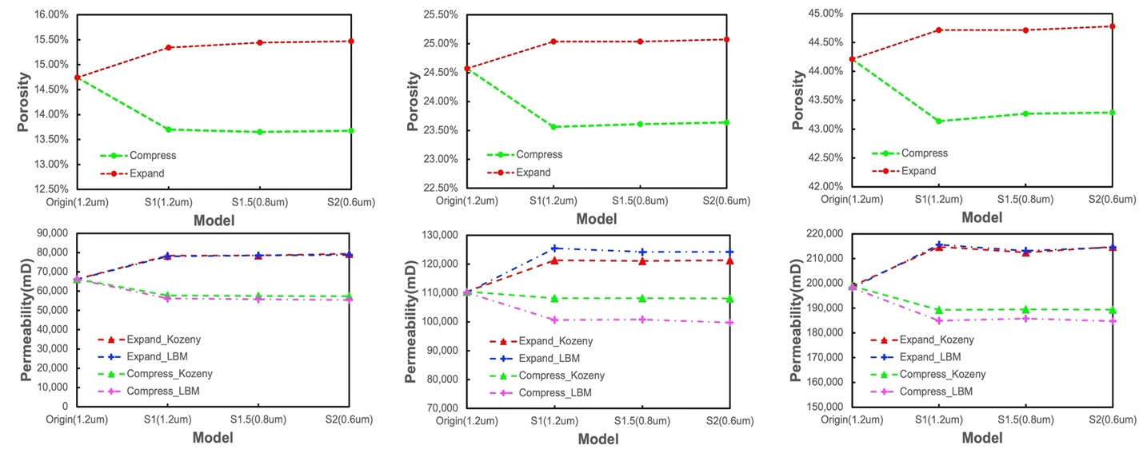
(a) Model 1 (b) Model2 (c) Model3
Figure 2 Porosity and permeability of original and deformed models. The first row shows the porosity of three models after resampling their deformed models at three resolutions (S1=1.2 um, S1.5 = 0.8 um, and S2 = 0.6 um) and the second denotes permeabilities. The simulated permeabilities of three models after deformation are all in consistent with the Kozeny equation.

