Transition from viscous fingers to compact displacement during unstable drainage in porous media

Marcel Moura¹*, Fredrik K. Eriksen¹, Mihailo Jankov¹, Antoine L. Turquet² and Knut Jørgen Måløy^{1,3}

¹PoreLab, The Njord Centre, Department of Physics, University of Oslo, Oslo, Norway.
²NORSAR, Kjeller, Norway.
³PoreLab, Department of Geoscience and Petroleum, Norwegian University of Science and Technology, Trondheim, Norway.

We have performed a series of drainage experiments in a radial porous Hele-Shaw cell where we systematically varied the viscosity of the defending (wetting) fluid, and the overpressure of the invading (non-wetting) fluid to map out the resulting invasion structures as a function of viscosity ratio and injection pressure (see Figure 1). We described a cross-over from the viscous fingering instability to a compact invasion regime during viscously unstable drainage of porous media, and we investigated the underlying mechanisms of this compact fluid displacement. We have shown that above a threshold of injection pressure and for low enough viscosity of the defending fluid, a more stable and compact invasion structure emerges within the viscous fingering patterns, i.e. a roughly circular displacement with viscous fingers on the outside. We found that the ratio between the length of the outer fingers and the size of the compact invasion scales with the viscosity ratio of the fluid phases and approaches an approximately constant value during growth, resulting in structures with proportionate growth and larger compact invasions for lower viscosity of the defending fluid. As opposed to the viscous fingering instability, we observed rich ganglion dynamics within the compact invasion structures and showed that the pressure gradient is not screened by the outer fingers. We introduced a new concept called the flipping matrix to study the ganglion dynamics. Two global measures derived over this matrix allowed us to give a quantitative description of the intensity of the ganglion dynamics activity.

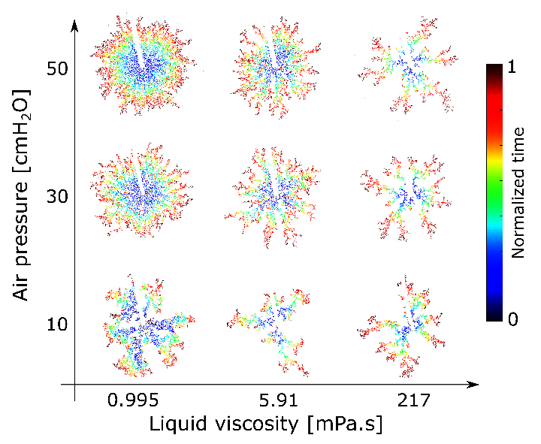
Figure 1: Diagram showing the air invasion pattern at breakthrough for 9 experiments in which the air pressure and the viscosity of the defending phase were varied. The colormap indicates the normalized time of invasion going from blue (start of the invasion) to red (breakthrough time).

References
[1] F. K. Eriksen, M. Moura, M. Jankov, A. L. Turquet and K. J. Måløy, “Transition from viscous fingers to compact displacement during unstable drainage in porous media,” Phys. Rev. Fluids 7, 013901 (2022).

*corresponding author: marcel.moura@fys.uio.no

