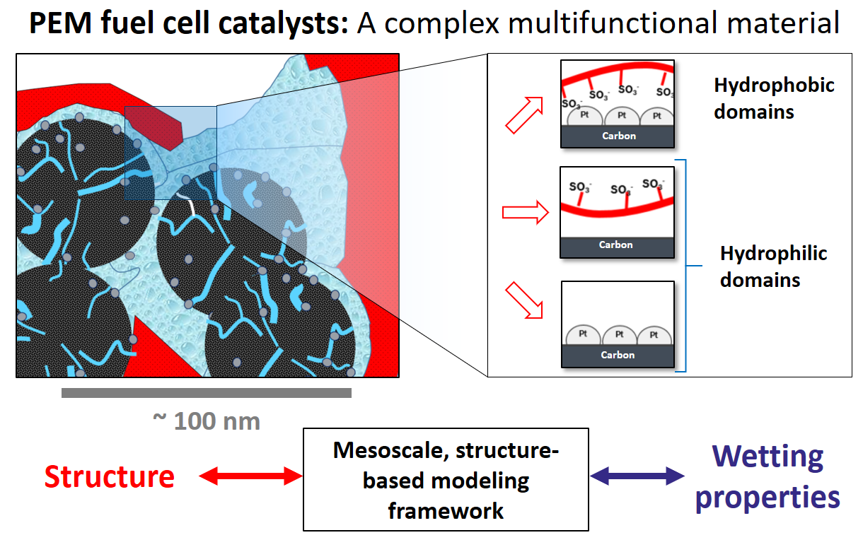
Fig 1.: Porous structure of a CCL with both hydrophilic and hydrophobic domains. The structure-based model accounts for the impact of the ionomer skin and it derives the wetting properties of the composite porous medium from surface properties of component materials (Pt, C, ionomer), the composition and microstructure.

