Effect of surfactants on liquid absorption into porous media
Surfactants play an important role in nearly the entire inkjet process including dispersion stability, jetting, spreading and absorption into porous media. In this work we used two main methods to extract the absorption dynamics of water and surfactant mixtures into porous media, namely Automatic Scanner Absorptiometer and a pico Liter drop watcher setup. Combining both methodologies it was possible to get information about the dynamics of liquid absorption into porous media.
The aim of this work is to study the consequences of surfactants on the absorption behaviour into porous media. For that, we used as surfactant the Surfynol series (104, 440, 465, and 485) mixed with water at CMC value. We studied in detail the increase of the hydrophilic part of the surfactant and correlate that with the absorption behaviour. This is performed for uncoated media and for coated media with a very different polarity (Inkjet vs Offset)
We have concluded that the structure of paper has a substantial effect on the interaction behaviour. For coated media we have seen little influence of the surfactant on the absorption behaviour; however for uncoated media we could have a difference on the absorption rate up to an order of magnitude. Furthermore we concluded that increasing the hydrophilic behaviour of the surfactant leads to a lower absorption rate.

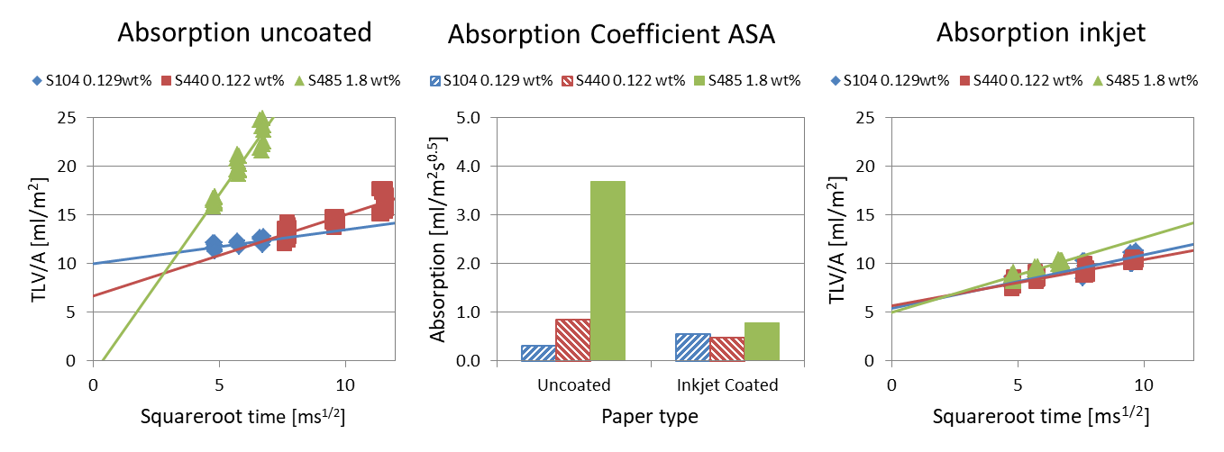
Figure 1- Absorption data from ASA. (left) Absorption graph of solutions on uncoated paper. (right) Absorption graph of solutions on inkjet coated paper. In the middle graph the slopes (absorption coefficients) are plotted.

Authors:
Hélder Salvador, Canon Production Printing, AM depart, R&D, Sint Urbanusweg 43, 5914 CA, PO Box 101, 5900 MA Venlo, The Netherlands, helder.marquessalvador@cpp.canon

Daniel Turkenburg, Canon Production Printing, AM depart, R&D, Sint Urbanusweg 43, 5914 CA, PO Box 101, 5900 MA Venlo, The Netherlands, daniel.turkenburg@cpp.canon

Jeroen Schell, Canon Production Printing, AM depart, R&D, Sint Urbanusweg 43, 5914 CA, PO Box 101, 5900 MA Venlo, The Netherlands, Jeroen.schell@cpp.canon

Nicolae Tomozeiu, Canon Production Printing, AM depart, R&D, Sint Urbanusweg 43, 5914 CA, PO Box 101, 5900 MA Venlo, The Netherlands, Nicolae.Tomozeiu@cpp.canon

Analysis of droplet spreading versus droplet absorption using ASA and pico-liter setup, Joep Sanders, 2021
Dynamics of fluid mixtures and nanoparticles during capillary suction, Cornelis Kuijpers, 2018
Dynamic behaviour of pl droplets on substrates, Helder Salvador, 2019
Surfynol surfactants, IMCD. https://www.imcdus.com/en-us/products/surfynol-surfactants

