Visualization Research of Clay Mineral Migration Under Low Salinity Water Flooding Based On 2.5D Microfluidic Model

Author Block: F. Xu, H. Jiang, S. Qu, F. Yu, J. Li, State Key Laboratory of Petroleum Resources and Prospecting, China University of Petroleum (Beijing)

Abstract:
Objectives/Scope: There have been many reports on EOR by low salinity water flooding. An inevitable problem of low salinity water flooding is that clay minerals would undergo hydration expansion and be washed off from the rock, and then migrate in the pore throat. In this study, a 2.5D visualized microfluidic model is used to observe and analyze various phenomena during the migration of clay minerals, including blockage in the throats and adsorption of clay minerals on the surface of crude oil, as well as their effects on oil recovery.
Methods, Procedures, Process: A 2.5D microfluidic model is prepared that has a homogeneous porous structure with micro-sized pore throats. A mixture of chlorite and low salinity water would be injected into the model to simulate the migration of clay minerals. And three groups of experiments are designed, including the clay mineral migration experiment with or without crude oil being pre-saturated, and the control experiment of low salinity water drive crude oil without clay mineral. Then the phenomena of clay mineral migration would be visualized under the microscope.
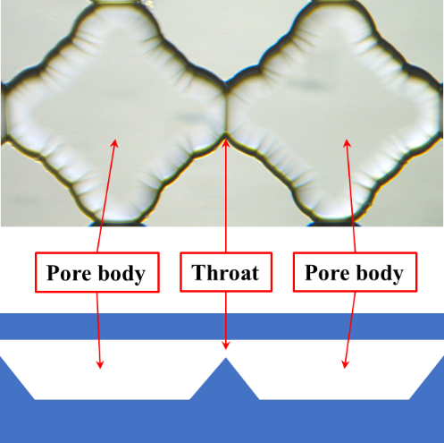
Pore throat structure
Results and Observations: We have observed the phenomenon that clay minerals gradually accumulate at the throat and block the throat. And we also found that when the injection speed is low, the clay minerals could migrate to the throat far away from the entrance and block the throat. After the speed is significantly increased, clay minerals would tend to accumulate and block the throat at the entrance. This phenomenon indicates that the displacement speed of low-salinity water flooding should not be too high. We have also observed the phenomenon that clay minerals were adsorbed on the surface of oil droplets. The occurrence of this phenomenon would increase the migration resistance of oil droplets, which is not conducive to the exploitation of crude oil. In addition, we have also observed the phenomenon that the water phase diffused into the oil phase under low salinity water flooding. This phenomenon has been reported in many papers as one of the important oil displacement mechanisms of low salinity water flooding.
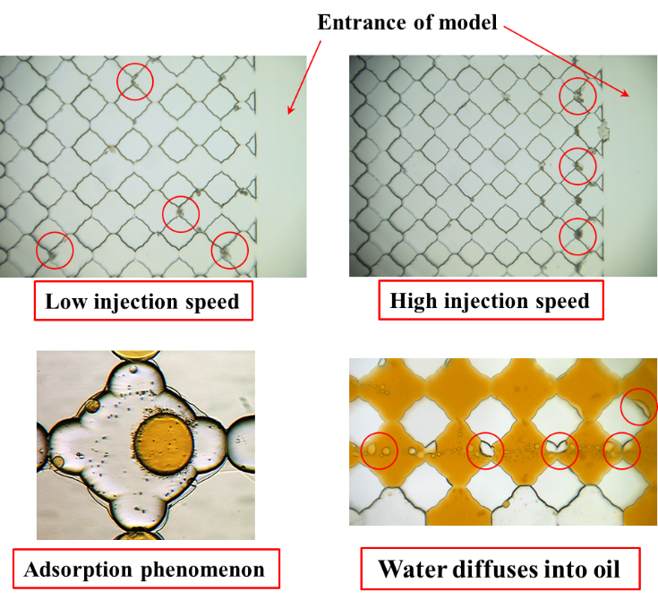
Novel/Additive Information: The migration of clay minerals is a common phenomenon in low-salinity water flooding. However, there are few visual studies on the migration of clay minerals. Based on the 2.5D visualization microfluidic model, this study observed the phenomena that occurred during the migration of clay minerals and analyzed their influence on oil recovery, which would be helpful to improve the understanding of the role of clay minerals migration.

