Non-destructive 3D mapping of mineral composition and clay mineral orientation in shale
Fredrik K. Mürer¹, Aldritt S. Madathiparambil¹, Kim Robert Tekseth¹, Pierre Cerasi², Basab Chattopadhyay¹, Dag W. Breiby^{1,3}
¹PoreLab, Department of Physics, Norwegian University of Science and Technology (NTNU), Høgskoleringen 5, 7491 Trondheim, Norway
²SINTEF Petroleum Research, Formation Physics dept, PB 4760 Sluppen, 7465 Trondheim, Norway
³Department of Microsystems, University of South-Eastern Norway (USN), Campus Vestfold, 3184 Borre, Norway

Shales are sedimentary rocks with a complex mineralogy, where the mechanical properties are predominantly determined by the orientation of clay minerals^{[1]}. Shales are increasingly studied, due to their use as cap rocks in carbon capture and storage (CCS) technologies. Attenuation-contrast computed tomography (CT) allows three-dimensional (3D) imaging of the microscale morphology, also allowing identification of some high-density inclusions. However, attempts at segmenting the attenuation-CT tomograms can be ill-defined or even impossible, as the hierarchical material contains mineralogical features at the nanoscale^{[2]}, thus giving partial volume effects precluding reliable assignment of sample compositions to the observed grayscale values. Better methods for 3D non-destructive imaging of shales are therefore in high demand.
X-ray diffraction computed tomography (XRD-CT) is a recent 3D imaging technique relying on synchrotron X-ray diffraction (XRD) as a mineral-sensitive contrast mechanism^{[3]}. The chemical composition and mineralogy can be spatially resolved with micrometre resolution, allowing 3D mapping of minerals, which is crucial to image samples where physical sectioning of the samples risks changing the delicate sample microstructure, as is the case for shales. The diffracted X-rays additionally provide information about the crystallite orientation found in the sample, and can be mapped in 3D using X-ray diffraction tensor tomography (XRDTT)^{[4–7]}, which is a recent extension of XRD-CT.
Here, we demonstrate the use of XRD-CT to study the mineralogy and clay mineral orientation in Pierre shale. Figure 1a sketches an XRD-CT setup for measurement of a ~3 mm diameter cylindrical sample of Pierre shale. A large number (~10⁵) of diffraction patterns were collected, and these contain information about the mineral composition and crystallite orientation. A corresponding attenuation-contrast CT cross-section is shown in Fig. 1b, revealing that the sample contains several highly attenuating mineral inclusions. The clay minerals are predominantly oriented with their stacking layer normal along the bedding direction (coinciding with the sample cylinder axis, see Fig. 1c). Notably, a band of a slightly different orientation is seen to stretch diagonally across the sample. By using XRDTT analysis, the clay mineral orientation is reconstructed in 3D, and regions of varying clay mineral preferred orientation in the samples are revealed, as shown in Fig. 1d. Additionally, high-density isotropically scattering mineral inclusions were found, and by the XRD analysis, these inclusions could irrevocably be concluded to contain pyrite.
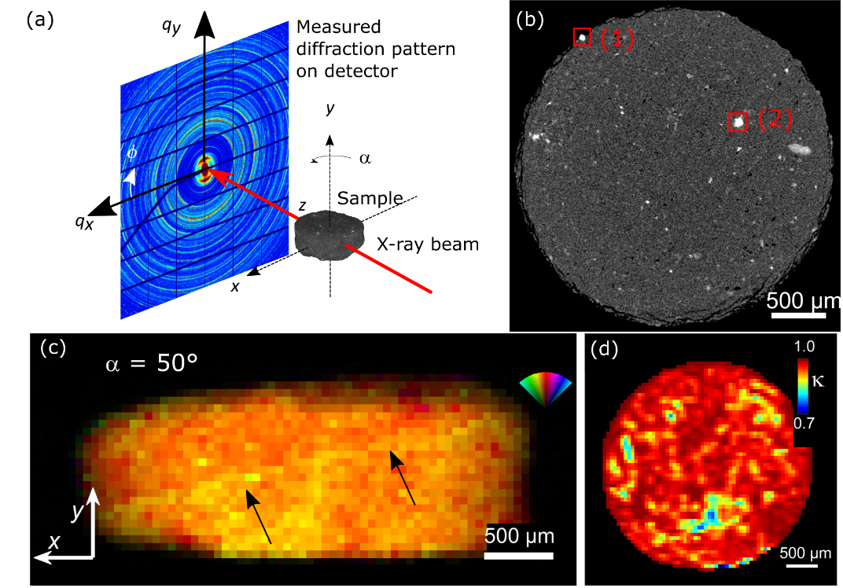
Figure 1 3D mapping of shale using XRD-CT. (a) Experimental setup. (b) Attenuation-contrast CT cross-section where two high-density inclusions have been indicated with red rectangles. (c) Dominating scattering direction of the clinochlore 001 Bragg peak. The black arrows point to a plane of varying clinochlore orientation observed in the sample. (d) XRDTT cross-section of clinochlore orientation. κ is the dot-product between the local clinochlore orientation and the tomography y-axis.
While the voxel size in the current experiment was 50 μm, the continued experimental developments should in the near future allow resolutions below 100 nm. Our results show that XRD-CT/XRDTT is fast becoming a powerful method to study the complex structure of shales.
Acknowledgements
We are grateful to the Research Council of Norway for financial funding through FRINATEK (#275182) and its Centres of Excellence funding scheme (#262644).
References
[1] L. Leu, A. Georgiadis, M. J. Blunt, A. Busch, P. Bertier, K. Schweinar, M. Liebi, A. Menzel, H. Ott, Energy and Fuels 2016, 30, 10282.
[2] B. Chattopadhyay, A. S. Madathiparambil, F. K. Mürer, P. Cerasi, Y. Chushkin, F. Zontone, A. Gibaud, D. W. Breiby, J. Appl. Crystallogr. 2020, 53, 1562.
[3] G. Harding, J. Kosanetzky, U. Neitzel, Med. Phys. 1987, 14, 515.
[4] M. Liebi, M. Georgiadis, A. Menzel, P. Schneider, J. Kohlbrecher, O. Bunk, M. Guizar-Sicairos, Nature 2015, 527, 349.
[5] E. T. Skjønsfjell, T. Kringeland, H. H. H. H. Granlund, K. Høydalsvik, A. Diaz, D. W. Breiby, IUCr, J. Appl. Crystallogr. 2016, 49, 902.
[6] F. K. Mürer, S. Sanchez, M. Álvarez-Murga, M. Di Michiel, F. Pfeiffer, M. Bech, D. W. Breiby, Sci. Rep. 2018, 8, 1.
[7] F. K. Mürer, B. Chattopadhyay, A. S. Madathiparambil, K. R. Tekseth, M. Di Michiel, M. Liebi, M. B. Lilledahl, K. Olstad, D. W. Breiby, Sci. Rep. 2020, 1.

