Self-assembly of Comamonas denitrificans: formation of a living bacterial gel

Sam Charlton¹, Gavin Melaugh², Eleonora Secchi¹

¹ Institute of Environmental Engineering, Department of Civil, Environmental, and Geomatic Engineering, ETH Zürich, 8093 Zürich, Switzerland,

² SUPA, School of Physics and Astronomy, University of Edinburgh, Edinburgh, UK

Corresponding author e-mail: charlton@ifu.baug.ethz.ch
Bacterial autoaggregation is a phenomena widely exhibited by environmental and pathogenic bacterial species [1]. Autoaggregation is mediated through surface bound and secreted proteins and polysaccharides and can act as a precursor to surface bound biofilm formation. Aggregation is considered a survival strategy, commonly induced by unfavourable growth conditions and low metabolic activity [2]. Polymer bridging and depletion attraction have been demonstrated to trigger autoaggregation, typically forming structures of compact disconnected clusters [4, 5].

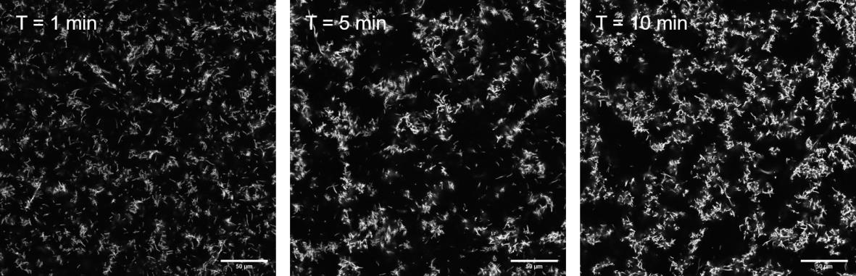
Comamonas denitrificans is a rod shaped filamentous bacterium found in abundance in wastewater environments which displays highly efficient denitrifying capabilities and exoelectrogenic activity in microbial fuel cells [6, 7, 8]. Our studies with this bacterium revealed autoaggregation which displays a distinct gelation phase transition at intermediate volume fractions ($ϕ>0.008)$. In this work we apply multiscale techniques from the soft matter toolbox to investigate the aggregation kinetics of Comamonas denitrificans. For the first time we show that bacterial autoaggregation can lead to self-assembly of space spanning fractal networks akin to attractive colloidal gels. By altering dissolved oxygen conditions during cell culture, we are able to reliably tune cell aspect ratio distribution and gel porosity creating a controllable living colloidal system. Using optical microscopy, we study the aggregation dynamics of low and high aspect ratio distributions, in the presence and absence of bacterial growth and in density matched and mismatched conditions. We compare the bacterial gel dynamics against Brownian dynamics simulations to further access the impact of aspect ratio distribution on the bacterial gel connectivity and porosity, and consider the impact of uniform or polar bonding locations. This work is a first look into self-assembled bacterial ‘living gels’.
Figure 1 Comamonas denitrificans autoaggregates into space spanning gel networks. Confocal microscopy slice of a time lapse of the formation of a bacterial fractal gel structure. Initially small clusters nucleate and branch with time to form a stress bearing 3D network. The timelapse was imaged 30µm above the coverslip using an overnight culture at an OD600 = 1.5 at 40x magnification, cells were labelled with syto 63.
[1] T. Trunk, H. S. Khalil, and J. C. Leo, AIMS Microbiol., vol. 4, no. 1, pp. 140–164, 2018.
[2] J. Klebensberger, A. Birkenmaier, R. Geffers, S. Kjelleberg, and B. Philipp, Environ. Microbiol., vol. 11, no. 12, pp. 3073–3086, 2009.
[3] G. Dorken, G. P. Ferguson, C. E. French, and W. C. K. Poon, J. R. Soc. Interface, vol. 9, no. 77, pp. 3490–3502, 2012.
[4] N. Cohen, H. Zhou, A. G. Hay, and A. Radian, Colloids Surfaces B Biointerfaces, vol. 182, p. 110361, 2019.
[5] L. Laganenka, R. Colin, and V. Sourjik, Nat. Commun., vol. 7, no. 1, p. 12984, 2016.
[6] S. Andersson, G. Kuttuva Rajarao, C. J. Land, and G. Dalhammar, FEMS Microbiol. Lett., vol. 283, no. 1, pp. 83–90, 2008.
[7] D. Xing, S. Cheng, B. E. Logan, and J. M. Regan, Appl. Microbiol. Biotechnol., vol. 85, no. 5, pp. 1575–1587, 2010.
[8] L. Gumaelius, G. Magnusson, B. Pettersson, and G. Dalhammar, Int. J. Syst. Evol. Microbiol., vol. 51, no. 3, pp. 999–1006, 2001.

