< Name >  <Affiliation and country> | Chairperson  Department of Petroleum Engineering  Louisiana State University, USA

InterPore2018 Conference – Attendance Certificate

This is to certify that name from affiliation attended the International Society for Porous Media (InterPore) held in New Orleans from 14th to 17th May 20178.
Thank you very much for your interest in InterPore.

With best regards,

Dr. Karsten Thompson, Local Organizing Committee Chair

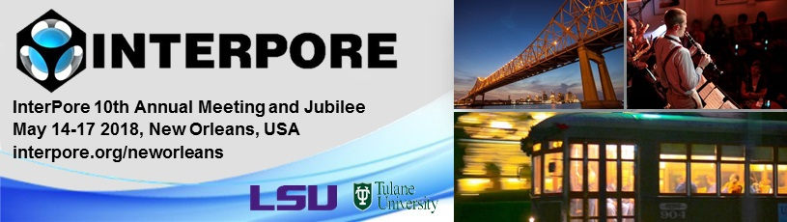

https://www.interpore.org/interpore-2018-new-orleans

