< Name >  <Affiliation and country> | Chairperson  Department of Petroleum Engineering  Louisiana State University, USA

InterPore2018 Conference – Presentation Certificate

This is to certify that name from affiliation attended the International Society for Porous Media (InterPore) held in New Orleans from 14th to 17th May 20178 and did an oral/poster presentation entitled:
“titel”.
Furthermore, he/she presented a poster entitled:
“titel”.

Thank you very much for your active contribution to InterPore.

With best regards,

Dr. Karsten Thompson, Local Organizing Committee Chair
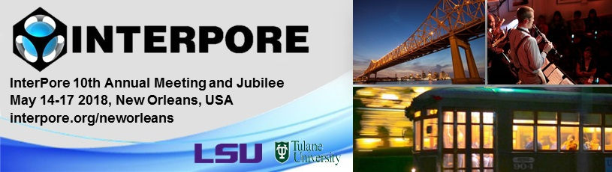

https://www.interpore.org/interpore-2018-new-orleans

