Investigation of water freezing in gas diffusion layer of PEMFC using lattice Boltzmann method
Lattice Boltzmann method, as a mesoscopic kinetic model between the macro-continuous model and the micro-molecular dynamics model, is a special discretization format, which is simple and efficient, and can solve the multiphase in complex geometric structures [1]. The characteristics of multi-component flow are widely used in solid-liquid phase change simulation. The key feature of the solid-liquid phase change problem is that the phase interface separating the solid and liquid phases dynamically evolves over time. The main challenge in simulating this problem is that the location of the phase interface is coupled with the heat transfer process.
The gas diffusion layer of PEMFC is a typical porous structure, composed of a carbon base layer with a complex pore structure and a microporous layer. In order to ensure the normal operation of PEM, it is usually necessary to maintain a water balance inside the cells. In this paper, the lattice Boltzmann method based on total enthalpy is used to simulate the water freezing problem under the two-dimensional scale in the reconstructed model of carbon paper GDL by using double distribution functions of velocity field and temperature field. Dimensionless time and dimensionless temperature distribution is used to characterize the freezing process of water. For the boundary condition of the velocity field, the standard non-slip rebound format is uniformly adopted, and for the boundary condition of the temperature field, the non-equilibrium extrapolation format is adopted [2]. The initial state is set to be that the pore area is evenly filled with liquid water. The left wall of the simulation object adopts a constant temperature boundary condition, a constant external low temperature is suddenly applied to the left wall, and the other three walls adopt a completely insulated boundary condition, so a phase change heat conduction channel can be formed between the left and right walls. The pore area starts to freeze from the left end, and the phase interface is unevenly shaped due to the influence of different thermophysical parameters of the porous medium. With the passage of time, the phase interface gradually moves to the right and the moving speed gradually becomes slower. The reason is that the temperature gradient in the liquid phase region becomes smaller, causing the heat transfer process to slow down.
In addition, the natural convection phenomenon during the freezing process is also considered. In the solidification process dominated by heat conduction, due to the combined effects of volume changes, density differences of various parts and gravity, fluid flow and heat transfer will occur in the flow field. In the simulation, streamlines are used to characterize natural convection phenomenon. The density of streamlines represents the intensity and the arrow represents the direction of natural convection. Through simulation, it is found that there is a counterclockwise fluid flow in the liquid phase region that has not frozen, and there obvious vortex in the closed pore region formed by randomly distributed carbon fibers, which indicates that the shape of the solid-liquid interface mainly depends on the distribution of carbon fibers.

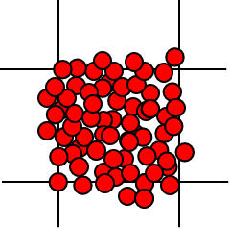 | 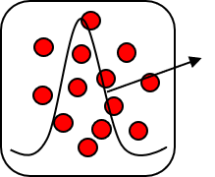 | 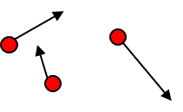
(a) macro-continuous model | (b) mesoscopic kinetic model | (c) micro-molecular dynamics model
Fig.1 Schematic diagrams of the basic unit of the simulation method for different observation scales

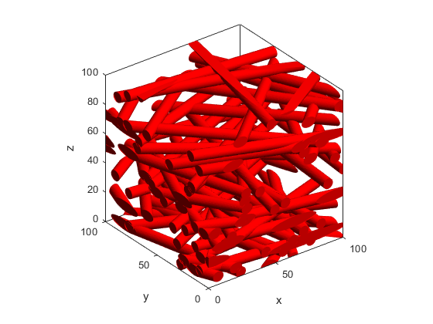 | 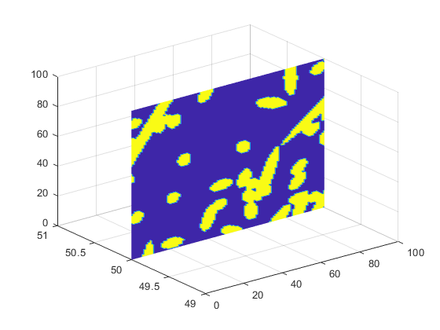
(a)3D reconstructed structure of carbon paper GDL | (b)2D cross section at 50% of the y axis
Fig.2 3D random reconstruction structure and 2D cross section of carbon paper gas diffusion layer

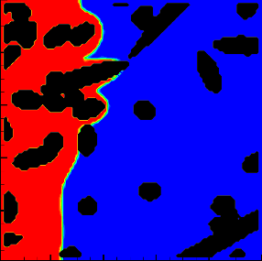 | 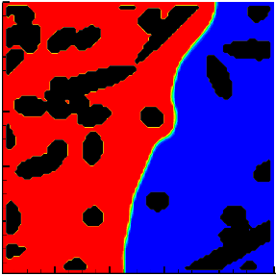 | 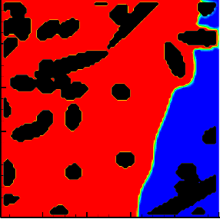 | 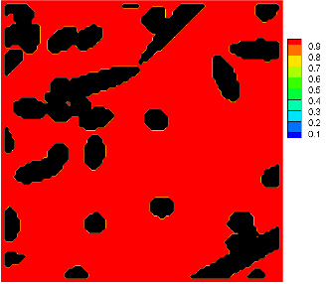
0.25 | 0.50 | 0.75 | 1.0
(a)ice fraction
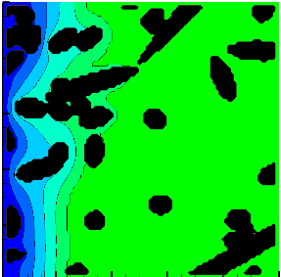 | 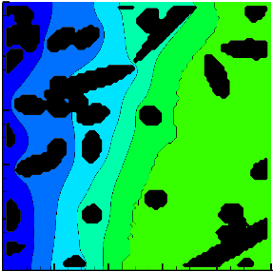 | 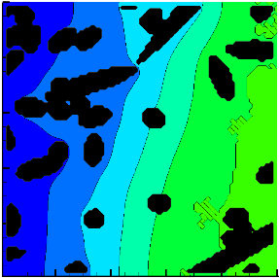 | 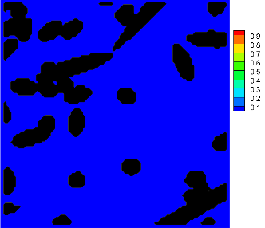
Fo=0.49 | Fo=1.21 | Fo=2.26 | Fo=3.83
(b)dimensionless temperature distribution
Fig.3 Cloud diagram of ice volume fraction and dimensionless temperature distribution over time

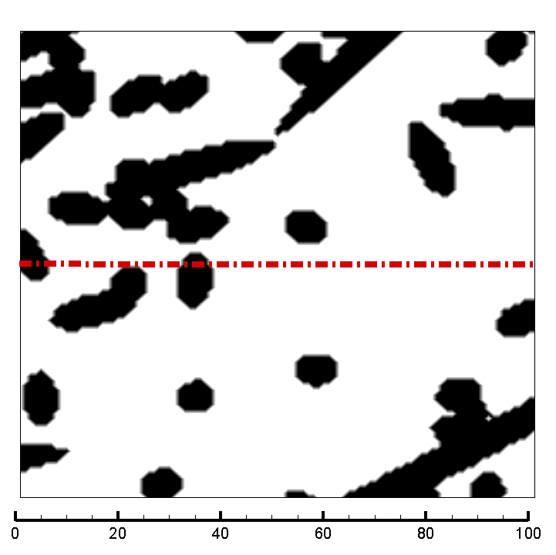 | 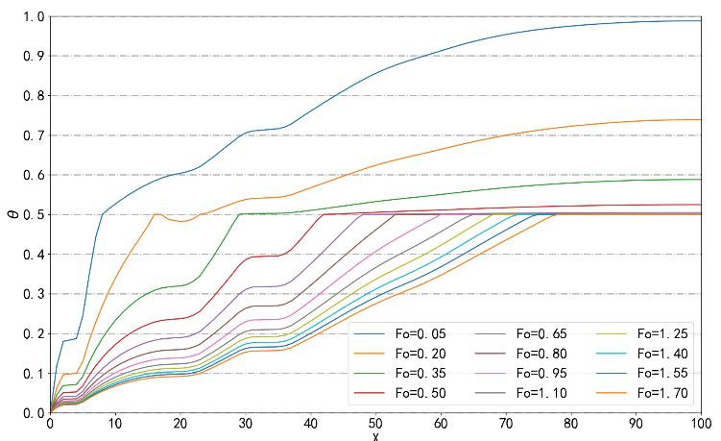
(a) 2D cross section at 50% of the y axis | (b)dimensionless temperature cure along the x-axis at different Fo
Fig.4 Dimensionless temperature distribution changes

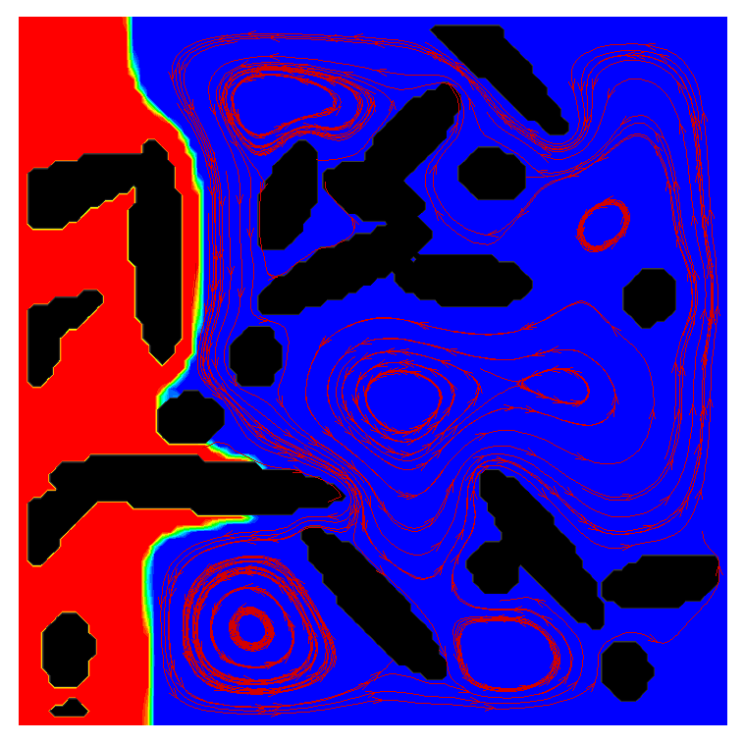
Fig.5 Natural convection during freezing process in carbon paper 2D section

- LUO K H, XIA J, MONACO E. MULTISCALE MODELING OF MULTIPHASE FLOW WITH COMPLEX INTERACTIONS[J]. Journal of Multiscale Modelling, 2009, 01(01): 125–156.
- GUO Z, ZHENG C, SHI B. Non-equilibrium extrapolation method for velocity and pressure boundary conditions in the lattice Boltzmann method[J]. Chinese Physics, 2002, 11(4): 366–374.

