Coffee is for drinking, tea is for porous media science: intermittent burst dynamics in slow drainage experiments in porous media
Marcel Moura¹*, Knut Jørgen Måløy¹, Eirik Grude Flekkøy¹ and Renaud Toussaint^{1,2}
¹PoreLab, The Njord Centre, Department of Physics, University of Oslo, Oslo, Norway.
²University of Strasbourg, Institut de Physique du Globe de Strasbourg, CNRS UMR 7516, Strasbourg, France.

We start with a very simple experiment that you can reproduce in your own kitchen. Being stuck in this home office business does not mean we have to stop with the experimental activity! Make yourself some tea. No fancy loose-leaf tea, just the regular teabag from the store around the corner. Place the teabag in a cup and after you are happy with the tea’s strength, remove the bag and place it on top of a napkin (preferably on a plate or something to control the mess in your kitchen). You can now get rid of tea, the teabag is all that matters, that’s where the porous medium is. Watch it closely: you will see that as the napkin gets wet, pockets of air suddenly enter the void spaces between the tea leaves, in a very abrupt fashion. This kind of intermittent invasion dynamics is common to all types of drainage experiments in porous media. We have studied this behavior experimentally using artificial micromodels that (unlike the tea), are completely transparent, thus allowing us to visually track the whole invasion dynamics. We have measured the pressure fluctuations resulting from the intermittent burst activity, and showed how different boundary conditions (controlled imposed pressure vs. controlled withdrawal rate) lead to very different pressure signatures. We have shown how statistical signatures of the pressure fluctuations can encode important information about the porous medium and the liquids involved.

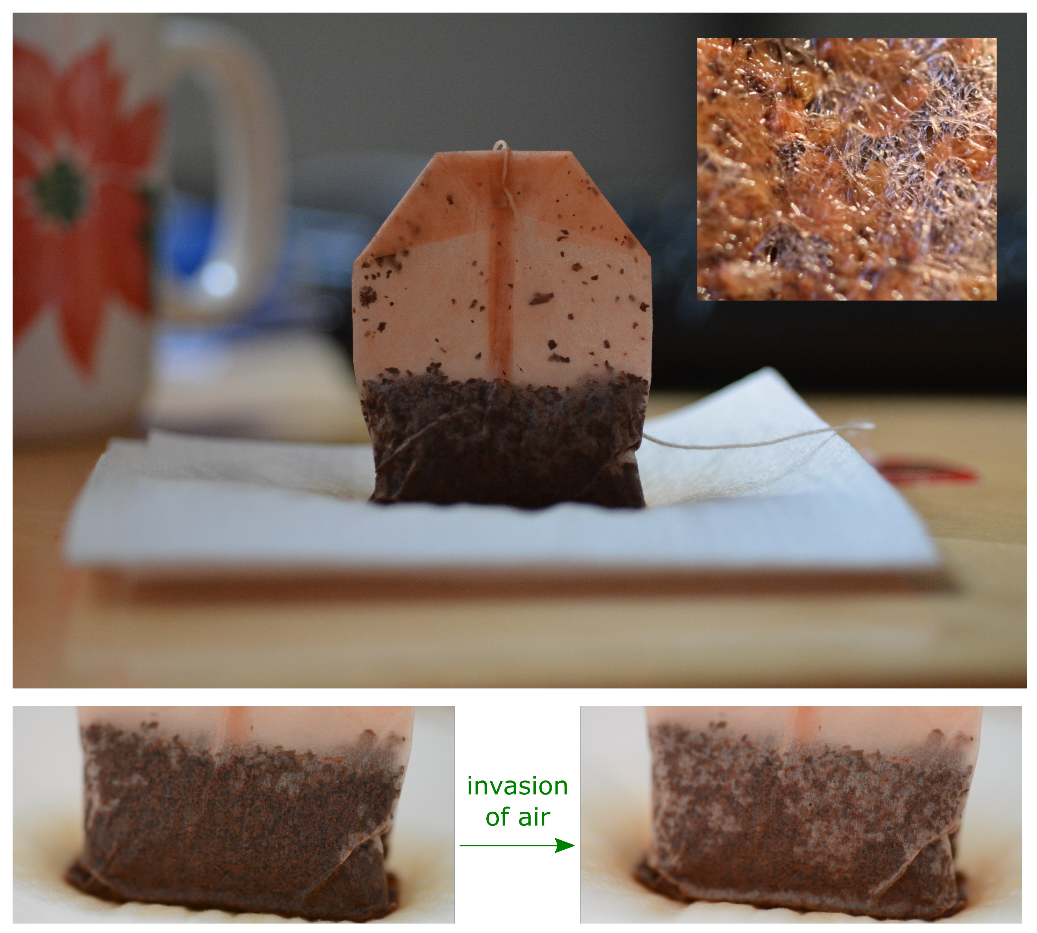
Figure 1: A wet teabag placed on top of a napkin. As the napkin gets wet, pockets of the surrounding air invade the void spaces between the tea leaves, in an interesting intermittent manner. This curious invasion pattern is common to all slow drainage experiments in porous media.

References
[1] M. Moura, K. J. Måløy, E. G. Flekkøy, and R. Toussaint, “Intermittent dynamics of slow drainage experiments in porous media: Characterization under different boundary conditions”, Front. Phys. 7, 217 (2020).
[2] M. Moura, K.J. Måløy, E.G. Flekkøy and R. Toussaint, “Verification of a Dynamic Scaling for the Pair Correlation Function during the Slow Drainage of a Porous Medium”, Phys. Rev. Lett. 119, 154503 (2017).

*corresponding author: marcel.moura@fys.uio.no

